|  |
| --- |
| ASE TEAM 1  USER DOCUMENTATION HUSACCT –GENERAL GUI & CONTROL  June 24, 2013 |

|  |
| --- |
| THIJS SCHALK - DONOVAN DE KUIPER - BART STEIJLEN  LEO WAKELKAMP - COEN VAN DRIEL |

CONTENTS

INTRODUCTION 3

SYSTEM REQUIREMENTS 4

GETTING STARTED 4

MENUS 5

FILE 5

NEW WORKSPACE 6

OPEN WORKSPACE 7

SAVE WORKSPACE 8

CLOSE WORKSPACE 9

EXIT 9

DEFINE 10

Define architecture 10

Define architecture diagram 10

Import architecture 10

Export architecture 10

ANALYSE 11

Application properties 11

Analyse application 12

Analysed application overview 12

ANALYSIS HISTORY 12

Analysed architecture diagram 12

VALIDATE 13

Validate now 13

Violation report 13

TOOLS 14

OPTIONS 14

HELP 15

ABOUT HUSACCT 15

DOCUMENTATION/HELP 15

TOOLBAR 16

Taskbar 17

ACTION LOG 18

# INTRODUCTION

This document will contain the general user documentation regarding the general graphical user interface and control of HUSACCT. If you would like to read more specific user documentation, we would like to refer you to the user documentation of that specific component.

# SYSTEM REQUIREMENTS

Processor 2Ghz-dualcore processor

Memory 2Gb

Hard disk 20MB available disk space

Display 1024x768 or higher

Operating system Any Java supported OS, preferably Windows 7

Additional Software Java JRE 1.7 Update 32 or higher

# GETTING STARTED

When using HUSACCT it is important to know in which order the functionalities can be used. HUSACCT differentiates between several states:

* NONE  
  *No workspace has been created or opened*
* OPENED  
  *A new workspace has been created or opened*
* DEFINED  
  *An logical architecture has been defined*
* APPSET  
  *Application details have been set*
* PRE_ANALYSED  
  *An application has been pre-analysed (required for progress bar)*
* ANALYSED  
  *An application has been analysed*
* MAPPED  
  *An analysed application has been mapped to the logical architecture*
* VALIDATED  
  *A mapped application has been validated*

The state you’re in defines the function you can use. For example, it is not possible to map an architecture to a physical application if the application has not yet been analysed.

# MENUS

## FILE

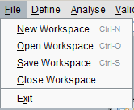

This menu allows you to manage your current workspace.

### NEW WORKSPACE

1. To create a workspace, go to file => New workspace.   
2. Choose a name for you workspace and select "Analyse Application".   
3. Give the application you want to analyse a name.  
4. Select the programming language.  
5. Give your application a version number (not the Java version number).  
6. Click on "Add" and select your project you want to analyse.  
7. Your workspace settings should look like something like this:

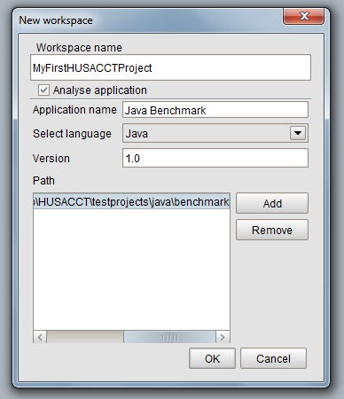

8. Click "OK" and HUSACCT starts analysing your selected project.   
9. During this process, you can start defining your architecture in the define screen that is also opened by HUSACCT.

### OPEN WORKSPACE

1. To open a workspace, go to file => Open workspace   
2. Select the file type (current only xml available)   
3. Choose the file you want to open using the "browse" button   
4. Click open   
5. When the file is password protected, you will be prompted for a password

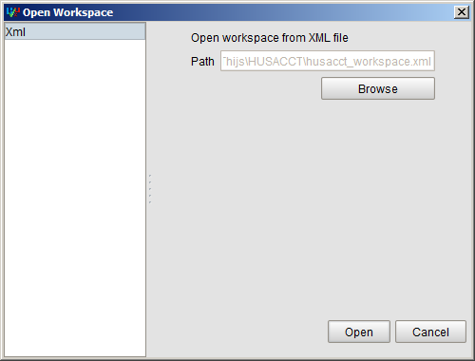

### SAVE WORKSPACE

1. To save a workspace, go to file => Save workspace   
2. Select the file type (currently only xml available)  
3. Choose a path using the "Browse" button  
4. There are a couple of options available:  
- Compress: Compresses the file to lower the required disk space  
- Password protection: Protect the file with a password, this makes the file unreadable when opening with a text editor  
5. Click "Save" and your workspace will be saved

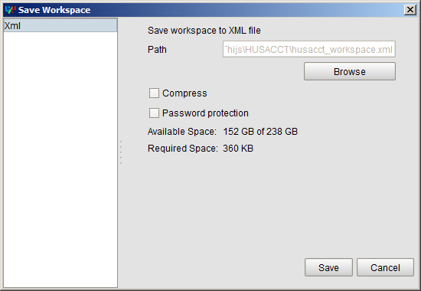

### CLOSE WORKSPACE

Start with a clean slate.

### EXIT

Close HUSACCT.

## DEFINE

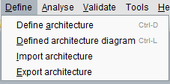

This menu allows you to define the architecture of your project source code in order to check the compliance against the actual architecture. For more specific information on this component, we hereby refer you to the user documentation of define.

### Define architecture

This enables the user to define a logical architecture and map an application to it. It is also possible to set architectural rules.

For more details on this component refer to the Define user manual.

### Define architecture diagram

This shows the user a graphical representation of the defined architecture.

For more details on this component refer to the Graphics user manual.

### Import architecture

Import a previously saved architecture into HUSACCT. The architecture file is XML.

### Export architecture

Export a defined architecture to file. HUSACCT only supports XML for exporting the architecture.

## ANALYSE

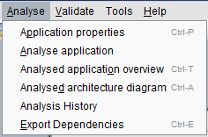

This menu allows you to analyse source code, view the results of the analysis and change application settings like the name of the application or the path to your source code.

### Application properties

This enables the user the set application properties. Users are able to save the properties so they can change any values. Or save & analyse which does exactly that, save the application properties and analyse the application. For more details on this component refer to the Analyse user manual.

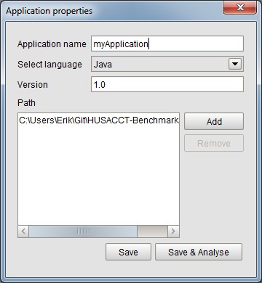

### Analyse application

Analyse the application.   
 For more details on this component refer to the Analyse user manual.

### Analysed application overview

Shows an overview of the analysed application. It also possible to show the dependencies between classes and packages. These dependencies can also be exported.   
For more details on this component refer to the Analyse user manual.

### ANALYSIS HISTORY

After analyzing any source code, HUSACCT saves information about the analysis in its App Data folder. This allows you to view the evolution of the software while your optimizing your code to get as few violations as possible. This analysis information can be found under Analyse -> Analysis History and looks like this:

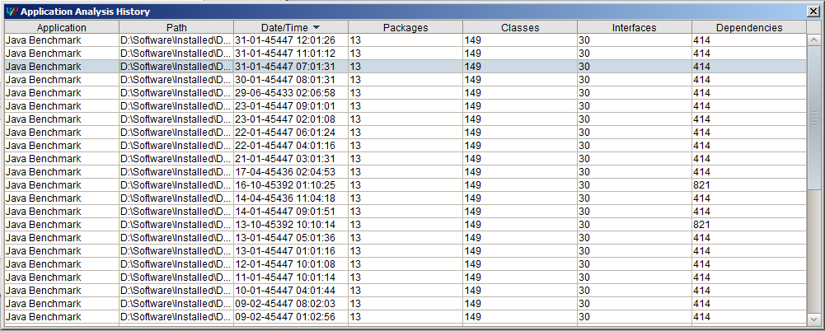

### Analysed architecture diagram

This shows the user a graphical representation of the analysed architecture.

For more details on this component refer to the Graphics user manual.

## VALIDATE

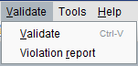

### Validate now

This enables the user to validate the application with the given architectural rules.

### Violation report

This enables the user to export a violation report. The report can be exported to PDF, XML or HTML.

## TOOLS



### OPTIONS

This will show you a window with all of HUSACCT configurable settings per component. You're able to change the language of HUSACCT, change your code viewer, enable action logger and more.

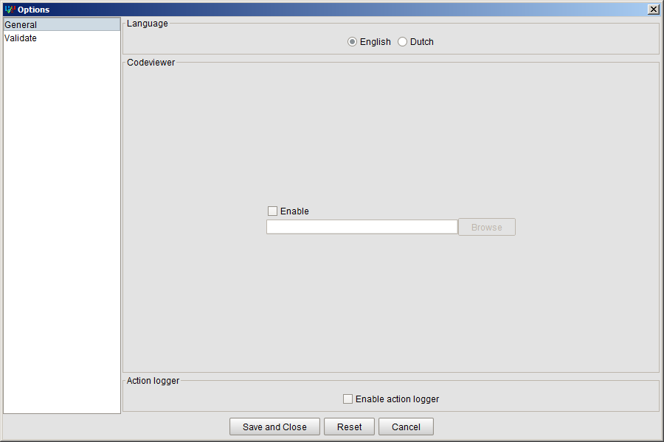

## HELP

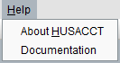

### ABOUT HUSACCT

This dialog shows you a little bit more info about HUSACCT like the version number, a link to github, all developers and engineers.

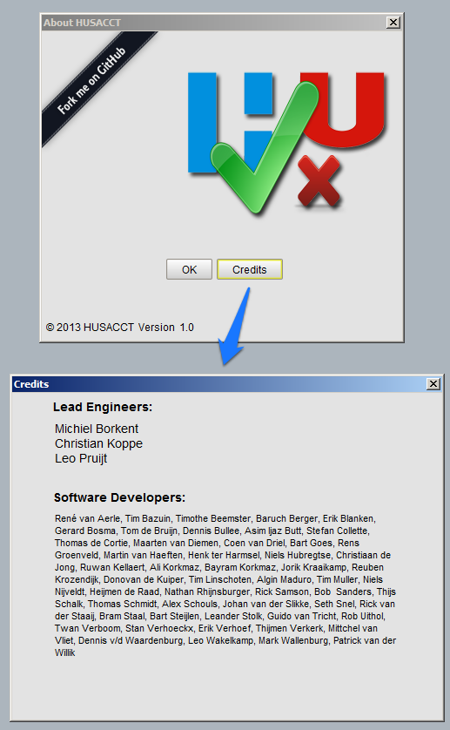

### DOCUMENTATION/HELP

Allows you to view the user documentation . These can be useful when you need more specific help. You can also right click on specific windows and hit Help. This shows a help dialog with step-by-step instructions.

# TOOLBAR

All the buttons in the toolbar are directly linked to the items in the menubar.



The buttons are from left to right:

* New workspace
* Open workspace
* Save workspace
* Define architecture
* Defined architecture diagram
* Application properties
* Analysed application overview
* Analysed application diagram
* Validate

# Taskbar

The taskbar is shown when a frame is opened.

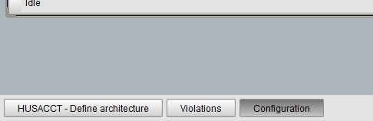

Left-click on a button will put the corresponding frame to the front.

Right-click on a button will open a context menu.

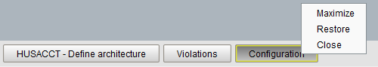

Maximize; maximizes the frame.  
Restore; sets the size of the frame to the default and centers the frame.  
Close; close the frame.

# ACTION LOG

The action log will show primary actions you've taken in HUSACCT. Say for example you've analysed a project. After analysing you'll see a message appear in the Action Log showing you the time you've analysed. The same goes for defining or validating. It is disabled by default and can be enabled in Tools -> Options -> General.

